FAZAIA BILQUIS COLLEGE OF EDUCATION FOR
WOMEN PAF NUR KHAN, RWP

Parallel Distributed Computing (LAB)
Lab 6 Tasks
Submitted to
Ma’am Iffat

Submitted by
Javeria Fazal
BSCS 7th B
F21-62

Task 1
Design and implement a simple UDP-based client–server program in C# to demonstrate that UDP does not guarantee reliable data delivery.
1. The client rapidly sends a sequence of numbered messages (e.g., “Packet 1”, “Packet 2”, ... “Packet 100”) to the server using UDP datagrams.
2. The server receives these packets and displays each message as it arrives.
3. After transmission, the number of received packets is compared to the number of sent
packets to observe any out-of-order arrival.
- Source Code Screenshot:
- Server Side:
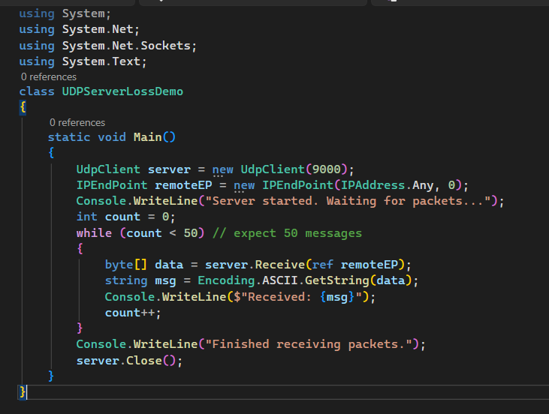
Figure 1: Server Side Code
- Client Side:
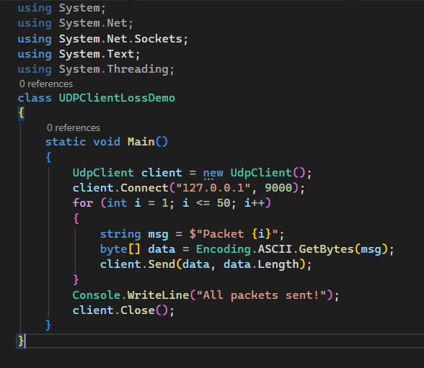
Figure 2: Client Side Code
- Output Screenshot:
- Client Side:
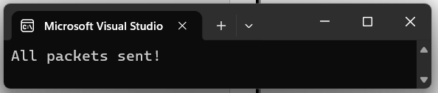
Figure 3: Output (Client)
- Server Side:
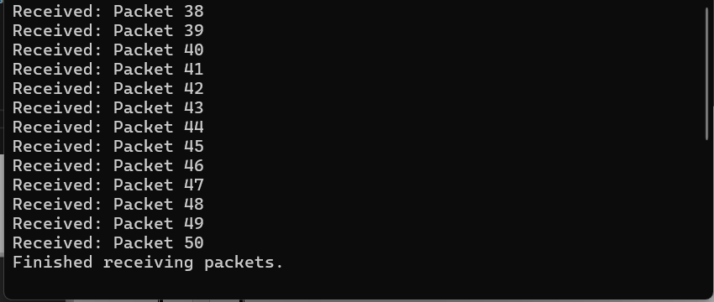
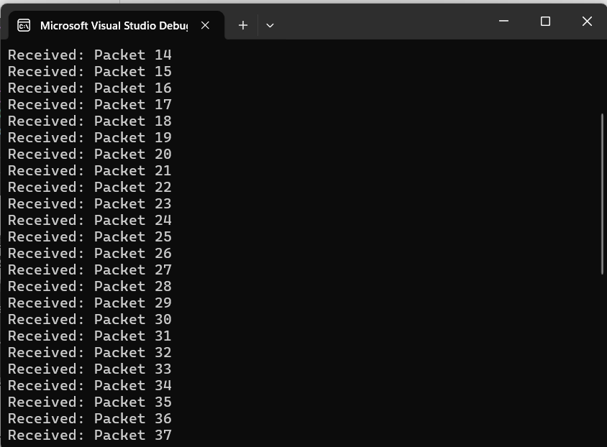
Figure 4: Output (Server)
Task 2
Design and implement a UDP-based client–server application in C# where the client and server communicate using datagrams.
1. The client sends an integer value to the server.
2. The server receives this integer, then prompts the user (on the server side) to enter another integer value.
3. The server adds both integer values and sends the sum back to the client.
4. The client then displays the received sum on its console.
- Source Code with Output Screenshot:
- Server Side:
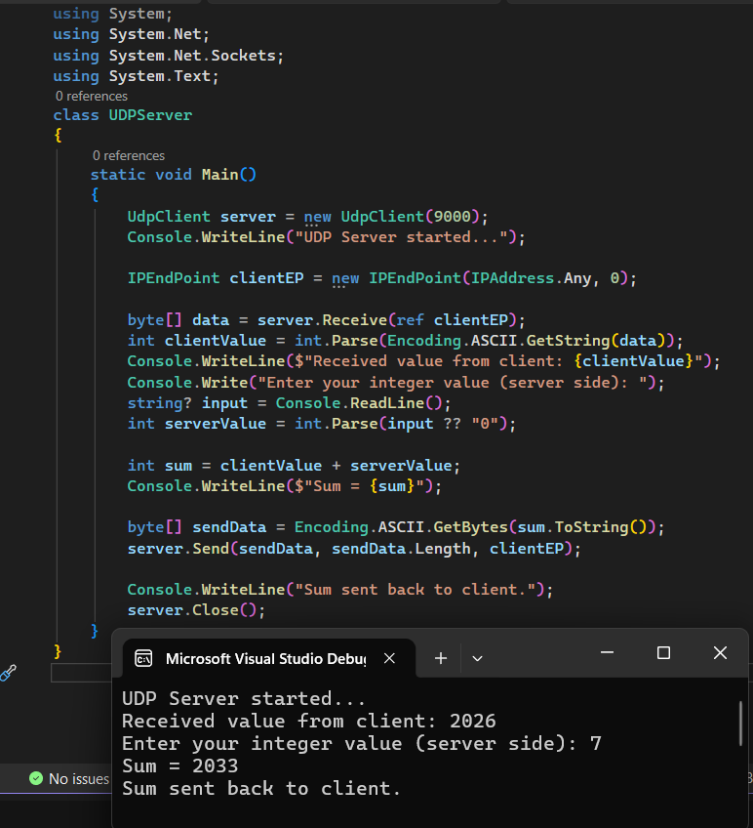
Figure 5: Server side with Output
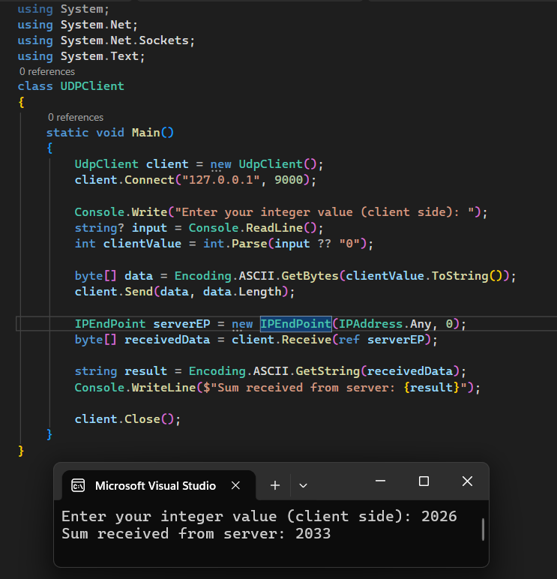
- Client Side with Output:

Task 3:
Develop a UDP-based client–server program in C# where the client sends an integer array to the server using the server’s local IP address.
1. Each array element is sent as a separate UDP packet containing its index and value.
2. The server receives these packets, reconstructs the original array in order, and displays it.
- Source Code with Output Screenshot:
- Receiver Side Side:
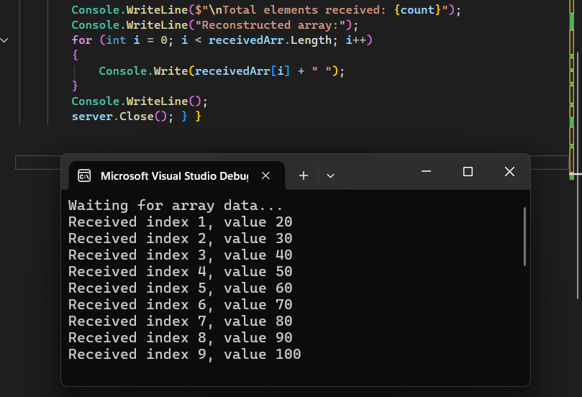
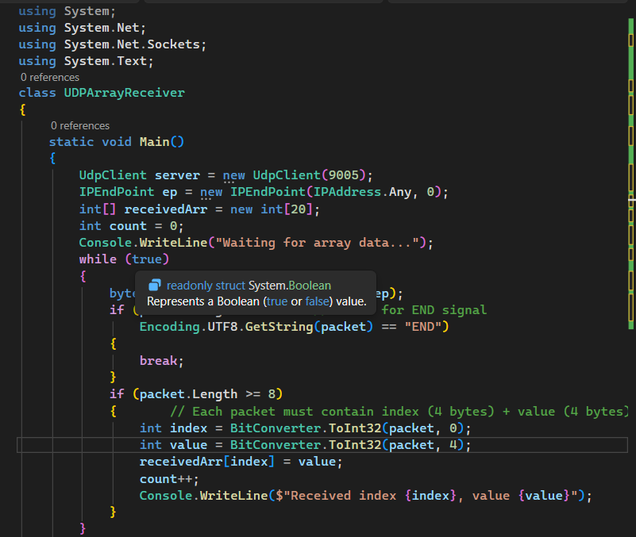
Figure 6: Receiver Side with Output

- Client Side with Output:

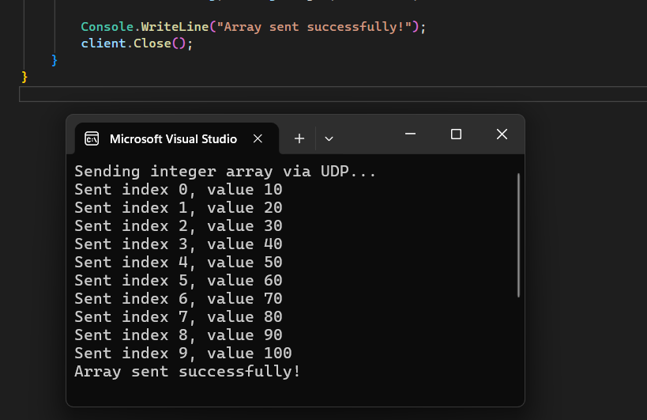
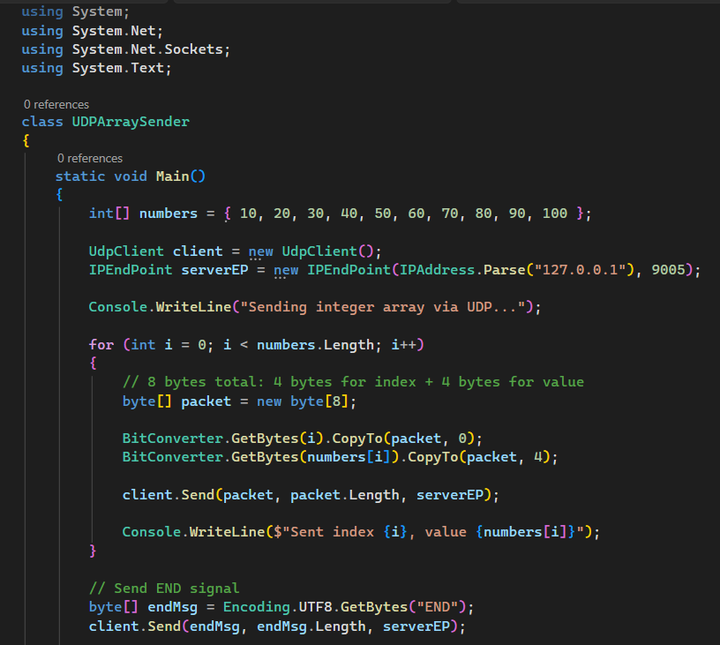
Figure 7: Sender side with output

